Procedures for calculating Relative wavelet energy

The following screenshot is from the reference: O.A. Rosso a,∗, M.T. Martin b, A. FigliolaEEG “analysis using wavelet-based information” Journal of Neuroscience Methods 153 (2006) 163–182

1. We do the discrete wavelet transform
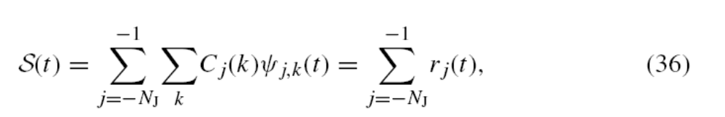
Where S(t) is the signal ,Cj(k) is the wavelet coefficient, and 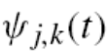is the mother wavelet
2.We calculate the relative energy
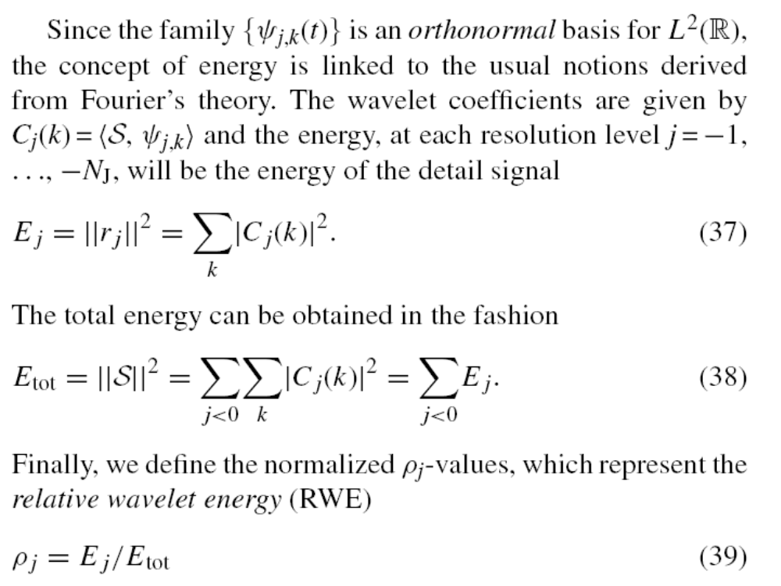
Please also note that
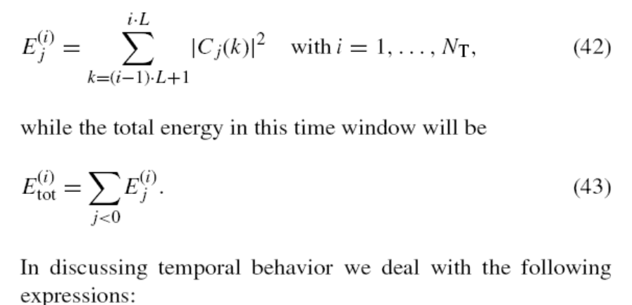
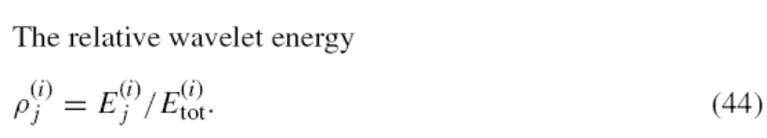
Note: L refers to the parameter:interval of function relative_energy
N_{j} refers to the parameter: levels of function relative_energy

Example:
We calculate the relative energy of the following signal composed of 3 parts
- sine wave of 200Hz sampled at 1000Hz lasting 10 second
- sine wave of 60Hz sampled at 1000Hz lasting 10 second
- random signal generated by matlab built-in function rand( )
t=1:0.001:10;
f1=200;
f2=60;
y1=sin(2*pi*f1*t);
y2=sin(2*pi*f2*t);
y3=2*rand(1,9001)-1;
y=[y1 y2 y3]’;

the signal is y in the file signal.mat

in command window,input
output1=relative_energy1(y,2^9,5);
which means that we choose interval to be 2^9=512,or approximately 512*0.001=0.512=0.5 second,and we make a 5 level discrete wavelet transformation
we got :
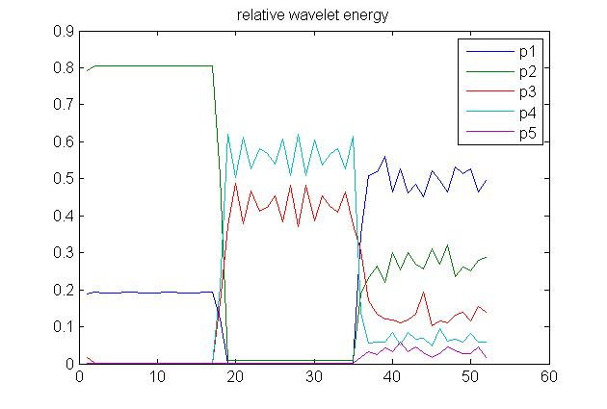
Where p1 is in the frequency domain of 250 -500 Hz
p2 is in the frequency domain of 125-250 Hz
p3 is in the frequency domain of 67.5-125 Hz
………………………………………………………..
We can see that the change in relative wavelet energy corresponds to the change in the frequency component of the original signal.

Made by: Guan Wenye (guanwenye@tju.edu.cn)

